CRIAR WIDGET

Na functions.php

// Registrando Sidebars

add_action( 'widgets_init', 'wpcurso_sidebars' );

function wpcurso_sidebars(){

register_sidebar(

array(

'name' => __( 'Home Page Sidebar'),

'id' => 'sidebar-1',

'description' => __( 'Sidebar to be used on Home Page', 'wpcurso'),

'before_widget' => '<div class="widget-wrapper">',

'after_widget' => '</div>',

'before_title' => '<h2 class="widget-title">',

'after_title' => '</h2>'

)

);

}

Na aparência widget vai aparecer

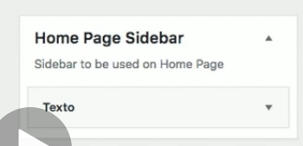

Onde podemos arrastar itens para lá

Na pagina insira

